Insurance Purchase System (Personal Auto)

Phase 1 - Requirement analysis

Debashis Jena

University of Maryland University College

Table of Contents

A. Problem definition 2

B. Issues 2

C. Objectives 3

D. Requirements 4

E. Constraints 5

F. Description 6

G. Logical model design 8

H. Specific requirements 11

I. References 14

# Problem definition

ABC Insurance Company sells policies for property and casualty. However, it specializes mainly in the personal auto line of business. Presently, policies are sold solely by the in-house agents and sometimes by the underwriters too. The entire policy purchase happens over a phone conversation. Since the internet has evolved to carry out these businesses efficiently and now even accessible on smart phones, ABC intends to take the most advantage of it. By doing business over the internet, many issues would be addressed, like customers’ misunderstanding of the coverages, deductibles, policy premiums, and discounts.

Additionally, the internet will be available 24x7 to create new businesses versus limited time availability of the agents, i.e. only during the business hours. Most importantly, today the internet has given consumers the power of self-service, so this move will improve the business significantly. This project is to create a self-service application for policy quoting and purchasing. The project stakeholders intend to utilize modern technologies and get the systems up and running within a year's time. This document is going to outline the requirement analysis and design.

# Issues

Business over the phone gives the customer a personal touch; however, it has many issues. Following is a list of significant issues that are affecting the business significantly.

1. For a customer, knowing the details of a product is very important. The terminology used in the insurance business is not easy to understand for a typical consumer. For an agent, explaining the details over a phone conversation is being very hard and time-consuming. In addition, if the customer does not speak the same language as the agent, that makes the agent’s job even harder.
2. The availability of the agents, is another issue. Since the number of agents is limited, the company loses some potential customers, who require an insurance policy during off-hours or very busy hours.
3. Since the insurance company intends to be PCI (Payment Card Industry Data Security Standard) compliant and follow General Data Protection Regulation (GDPR), reading the credit card number or the social security number over the phone must be controlled.
4. Without the ability of reading the lengthy terms and conditions page, customers filing chargebacks have increased drastically.

# Objectives

ABC Insurance Company intends to address the above issues. So, the objective of this project is to create an online self-service system where the customers will be able to create quotes, select their choice of coverages, assess their best options, securely buy the policy using their credit card. This application needs an automated way for the underwriter policy approval based on the named insured’s driving history. The existing form engine needs to be integrated with the application to generate the documents for the customer. When the new business policy has been created for the customer, an account needs to be created on the company’s website. In addition, the company intends to engage more with the customers and gather additional information about the customer, so that it can recommend and market other products to them; however, this will not be part of this project.

# Requirements

The current system consists of the integration of the following subsystems. (Figure D.1)

1. Policy Admin – Internal users access the policy admin system to create, edit, and cancel insurance policies for the users.
2. Billing – The policy admin is integrated with a billing system that generates one-time and recurring invoices and processes payments.
3. Forms – The forms engine generates the paper works for the policy, e.g. policy ID card, declaration page, and coverage descriptions.
4. Fulfillment – The policy id and declaration pages are emailed to the customers.

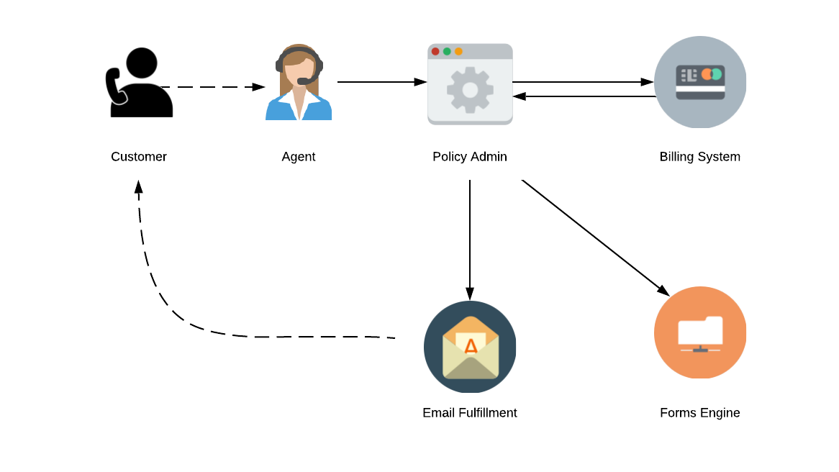

Figure D.1 Current policy creation process internally.

The proposed system is expected to go through the same process, but it will replace the need for an agent’s involvement and the policy admin system. Precisely, the application development will focus on creating a quote and converting the same to a new policy by processing the payment securely. (Figure D.2)

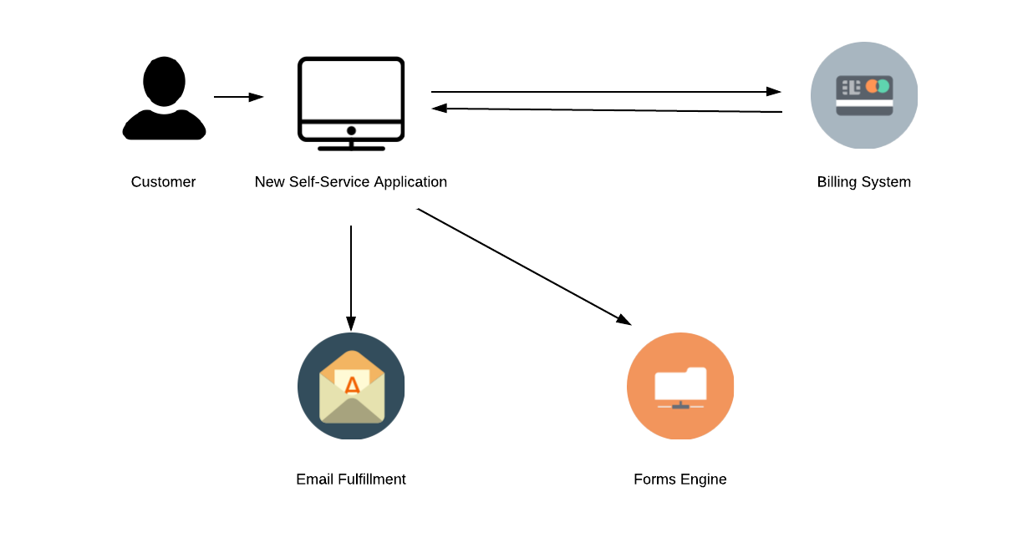 Figure D.2 Proposed self-service application

# Constraints

Since the proposed application is intended to be another layer on the current application, there will be the following constraints.

1. *Minimum to no modification to the current policy admin system* – Since the new application is expected to be improved, and to have high performance and convenient look and feel, the current underlying policy admin system may need to be refactored to some extent to be compatible with the new system. However, having a tight project deadline and limited budget, the new system will inherit some of the issues from the current system.
2. *Cloud infrastructure* – With the current policy admin system being hosted in the in-house data center, moving the new system to cloud may be a challenging task.

# Description

Self-service Quoting Application – High-level dataflow Specification (Figure G.1)

* + 1. Quoting & Select Plan
       1. The online portal to start a quote will be available on the company’s website.
       2. On the portal, the customer will be asked to enter the minimum number of required fields, along with the drivers’ incident and violation history.
       3. The base rates, as per the ISO (Insurance Services Office) rate manual, should be applied based on the coverage selected by the customer. The estimated premium would be displayed on the quote page.
       4. The system should also display some additional policy package recommendations to the customer.
    2. MVR (Motor Vehicle Records) Integration – Upon acceptance of the quote, the MVR report should be fetched for the underwriter approval.
    3. Underwriter Approval – Currently, this process is manual. However, it can be automated for some essential records, using a rules engine.
    4. Billing / Payments – If the policy is approved, the customer would be asked for the credit card information. Check option should also be available.
    5. Forms Engine – The insurance id card and declaration pages should be generated in a pdf format using merge fields.
    6. Authentication integration – After the policy has been created successfully, the customer should be asked to create an online account with the company. This account will be used by the customer to access the policy in the future. The online account also gives the ability to change the policy coverages, the payment methods or any other information like adding drivers and changing the mailing address. This is an existing application and development of which is not a part of the project scope; however, the integration is.

# Logical model design

1. Data flow diagram

The existing system allows the internal users to receive the customer’s call, enter the customer’s information, and the policy admin system would present a premium. The quoted premium may or may not be accepted by the customer. If the customer agrees to move forward with the policy then the user converts it to a new business or a full policy. The intended application is supposed to automate the process by having an user interface for the customers to directly enter the details and “self-checkout” a new policy. The proposed application is expected to contain the same external entity integration as the current policy admin system has. The below dataflow diagram shows the major external entities are MVR, Billing system and the forms engine.

Figure G.1.1 Data flow diagram.

1. Diagram 0 – Quoting Application

Figure G.2 Diagram 0

1. Descriptions of inputs/outputs and processes

* 1.0 - Enter Customer / Named Insured Information – Enter required customer details including Social Security Number (Required for credit check).
* 2.0 - Verify Exisitng Customer / Add New Customers – Processes the customers data by verifying if existing customer. If not, then a new entry is added to the database.
* 3.0 - Additional Driver Information – Customer is added as the first default driver. A policy can have additional drivers apart from the named insured. Driver’s license information and driving experience details is captured here.
* 4.0 - Vehicle Information – Vehicle year, make & model, along with the additional safety features and anti theft device information is entered in this process.
* 5.0 - Enter Coverages - Liability and Property Damage – Coverage information, including the coverage amount and deductible selections are made in this phase.
* 6.0 - Accident / Violation History – Motor Vehicle Registry api is used to get the driver’s accident and violation history. Based on this information, the underwriter may approve or reject the policy.
* 7.0 - Premium Calculation Display – Taking the state specific base rates for each of the coverages, the premium is calculated in this process.
* 8.0 - Billing / Payments – Secured payment transaction is done in this process. This phase will integrate with a separate system which currently is used in the policy admin system.
* 9.0 - Form Engine - Creates declaration page with the predefined merge fields in a pdf. Similarly, insurance policy ID cards are generated using a template pdf with merge fields.

# Specific requirements

1. Quoting application - The application must be designed based on the Insurance Services Office (ISO manuals). There are a few company specific exceptions to the manual. However, basic input and output for the quoting applications are as follows.
   * 1. Inputs –
        + Named insured information – Email, Name, SSN, Mailing address
        + Driver information – Age, Driving license, Driving experience, Relationship with the named insured
        + Vehicle Information – Year/Make/Model, Anti-theft device, Airbags, Other modern features like anti-crash radar
        + Coverage Information – Liability and physical damage
     2. Outputs – Calculated premium
2. MVR Integration

This is an integration of the quoting application with the MVR and will be executed when the quote is submitted for a new business. There will not be any exclusive screen for this process.

1. Inputs – Driver information including the SSN
2. Outputs – JSON formatted response with driver’s incident and violation history.
3. Security – Since the integration deals with the Personal Identifiable Information (PII) of the customer, extreme security measures must be taken to protect data security. All the information must be stored in an encrypted format. However, the company current IT security infrastructure is up to date in regards to cybersecurity and there no need to acquire additional systems or hardware to secure customer information.
4. Underwriter approval – The current approval process involves a manual review of the policy by the internal underwriters. For policy, it may take a few days to proceed to the next stage. In this project, the approval process will be automated.
5. Inputs – Accident & violation history of drivers with their severity (minor vs. major)
6. Control – The approval process involves a set of rules that analyzes the MVR report and evaluates if the customer can be approved in real time or be referred to the underwriters.
7. Billing / Payment – This is another part of the project that needs extreme security measures. As the company intends to become PCI compliant, the credit card information needs to be handled in an encrypted format; both at rest and in transit.
8. Inputs – Credit card details; Number, Expiration Month and Year, CVV number.
9. Control – The credit card information entered by the customer will be encrypted in transit. Once it has been validated via the payment gateway, a payment method id is created in the database.
10. Output – The PaymentMethodId from the database, which is used for payment processing.
11. Form Engine – The form engine is an existing system that is integrated with the current policy admin system. The same will be used for this application.
12. Inputs – Comprehensive policy information in JSON format.
13. Outputs – Insurance id card and policy declaration page in a pdf format.
14. Integration of Authentication system – This is an existing application. The integration will involve creating a new customer, if not already existing.
15. Inputs – Email id or user id, password
16. Output – The account will be saved in the customer database with authentication information.

# References

1. Dixit, J.B. & Kumar, R. (2007). Chapter 7 - Process Modeling. In *Structured system analysis and design*. [Books24x7 version] Retrieved from

*http://common.books24x7.com.ezproxy.umuc.edu/toc.aspx?bookid=30713*.

1. Owen, T. (2019, August 30). Buying Car Insurance Online vs From an Agent. Retrieved from *https://quotewizard.com/auto-insurance/agent-v-online*
2. Publishing, Silver Lake. (2008). Merritt personal lines insurance: liability coverages. [Books24x7 version] Retrieved from *http://common.books24x7.com.ezproxy.umuc.edu/toc.aspx?bookid=24811*.
3. No Author. (n.d.). Personal Auto Manual, Retrieved from *https://northstarmutual.com/UserFiles/File/agentmanual/ia/IApersonalauto.pdf*
4. No Author. (n.d.). Buying Insurance: Agent vs. Direct. Retrieved from *https://www.theinsurancescoop.com/get-the-scoop-on-insurance/agent-or-direct/*